|  |
| --- |
| **National University of Computer and Emerging Sciences** |
| Lab Manual 9  “Master Pages” |
|  |
| Database Systems |
| Spring 2018 |

Department of Computer Science

FAST-NU, Lahore, Pakistan

**Table of Contents**

1. Objective 4

2. Prerequisites 4

3. Task Distribution 4

4. Master Pages 5

5. ContentPlaceholder 5

6. Asp.net free Templates 5

7. Practice Exercise 5

# Objective

The purpose of this lab is to give you introduction to ASP.Net Master Pages and how to create a project using Master Pages.

# Prerequisites

Before this lab you should know how to create ASP.net web project, how to create new aspx Web Form. You should know the basic HTML and CSS too.

# Task Distribution

|  |  |
| --- | --- |
| Total Time | 170 Minutes |
| Introduction | 10 Minutes |
| Master Page Exercise | 30 min |

# Master Pages

Master pages allow you to create a consistent look and behavior for all the pages (or group of pages) in your web application.

A master page provides a template for other pages, with shared layout and functionality. The master page defines placeholders for the content, which can be overridden by content pages. The output result is a combination of the master page and the content page.

The content pages contain the content you want to display.

When users request the content page, ASP.NET merges the pages to produce output that combines the layout of the master page with the content of the content page.

For more info Visit

<http://www.w3schools.com/aspnet/aspnet_masterpages.asp>

<http://msdn.microsoft.com/en-us/library/wtxbf3hh.ASPX>

# ContentPlaceholder

In Web site development with ASP.NET, the Master Page contains a ContentPlaceHolder control that is used to define a region of the Master Page rendering that can be substituted with content from a page associated to the Master Page. You can get a clearer picture of the concept once you do the exercise listed below.

# Asp.net free Templates

You can find the free templates from following links.

<http://all-free-download.com/free-website-templates/sort-by-newest/>

The template than we used in this project can be downloaded using below link.

<http://all-free-download.com/free-website-templates/>

# Practice Exercise

**The following Exercise will demonstrated how to create and use Master Pages**

Step1: Create an empty asp.net Web Application. Name your Application ‘Lab9’ for simplicity.

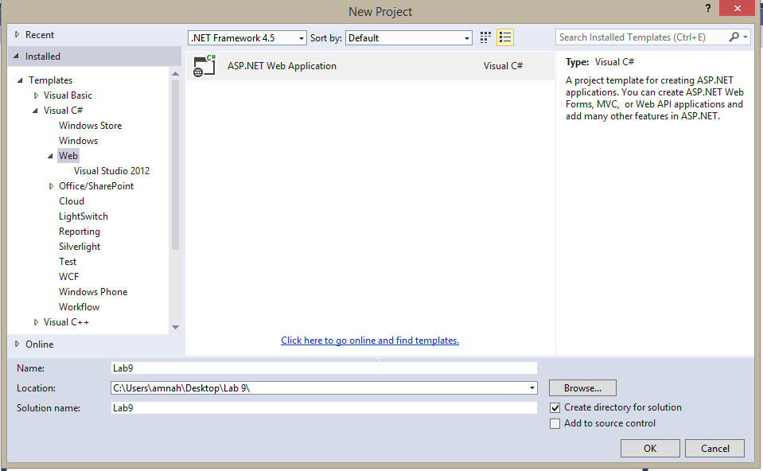

Select Empty template.

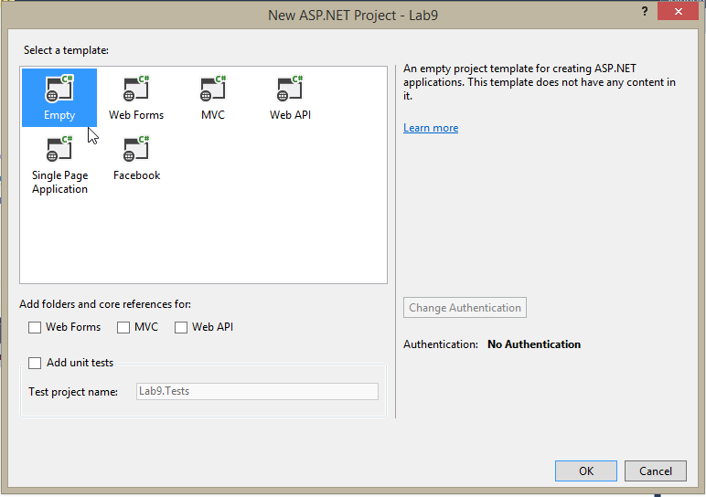

Step 2: Add a master Page like shown below. Name Your Master Page ‘Master’ for simplicity. 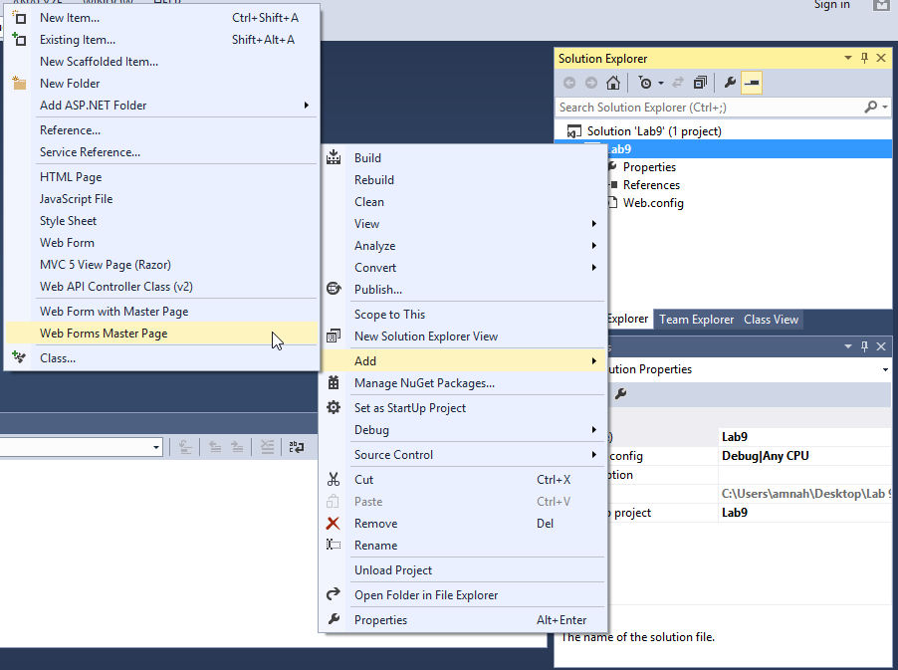

Step3: Now copy the contents of ‘MasterPage.txt’, given to you in resource folder, in your master page as below. 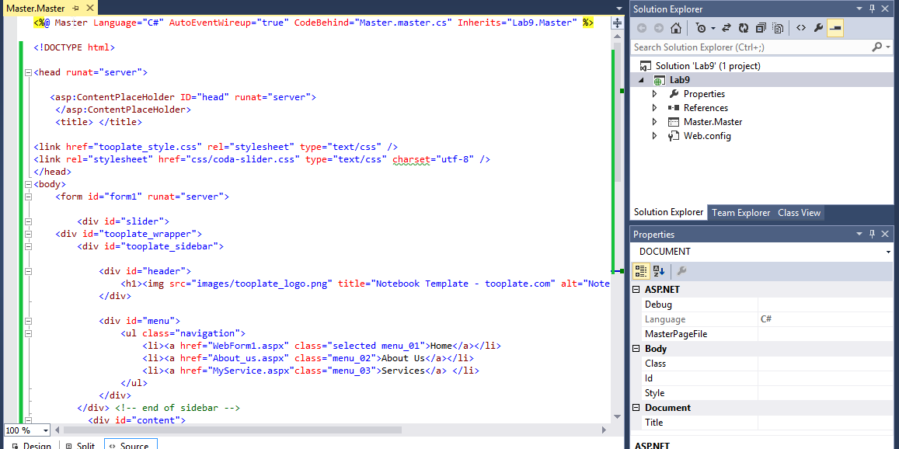

Step 4: Add a web form using Master Page as done in follwing image. Name your webform, ‘Home.aspx’ for simplicity.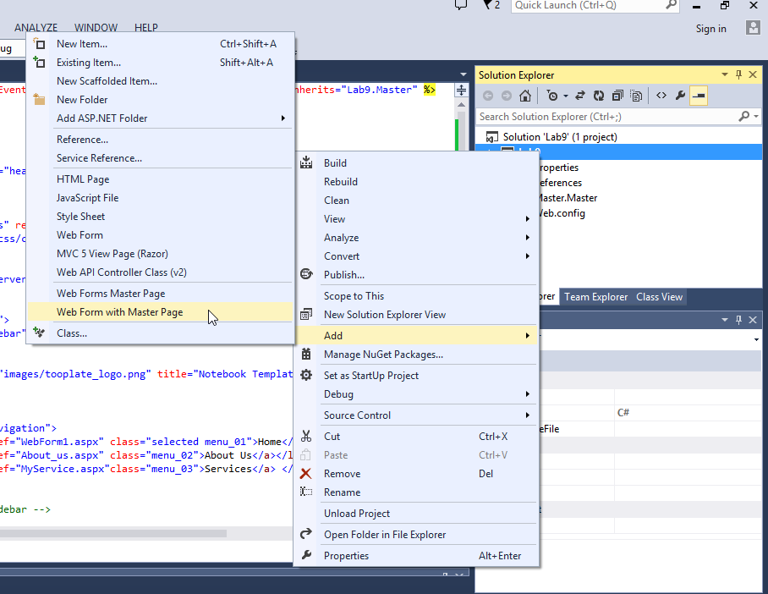S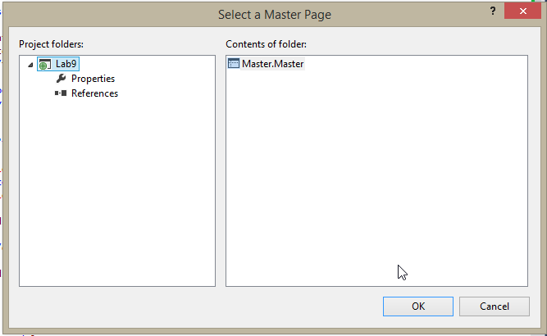

Step 5: Copy the content of ‘Home.txt’ in your webpage. ‘Home.txt’, is given to you in resource folder.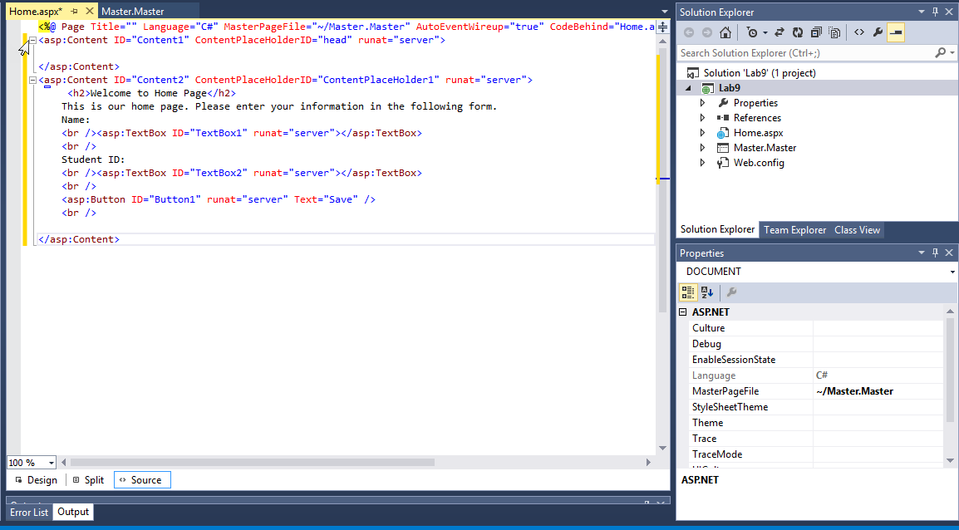

Step 6: Now create a folder in your application. For simplicity name it ‘Images’. After this add the images from image folder from resources.

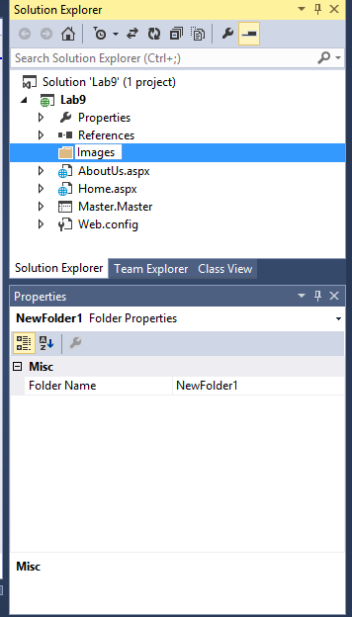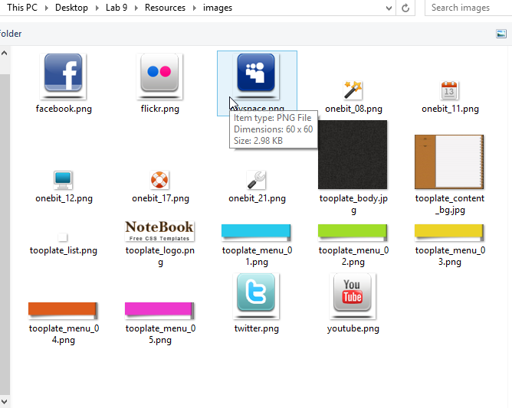

Step 6: Similarly create another folder ‘css’ and add css file from css folder given in resources.

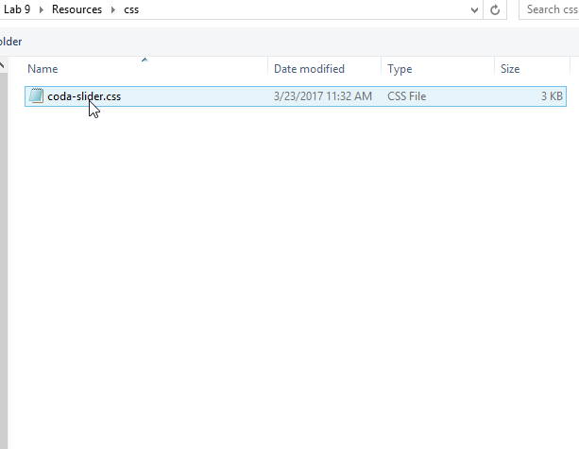Step 7: Now you can execute your project.

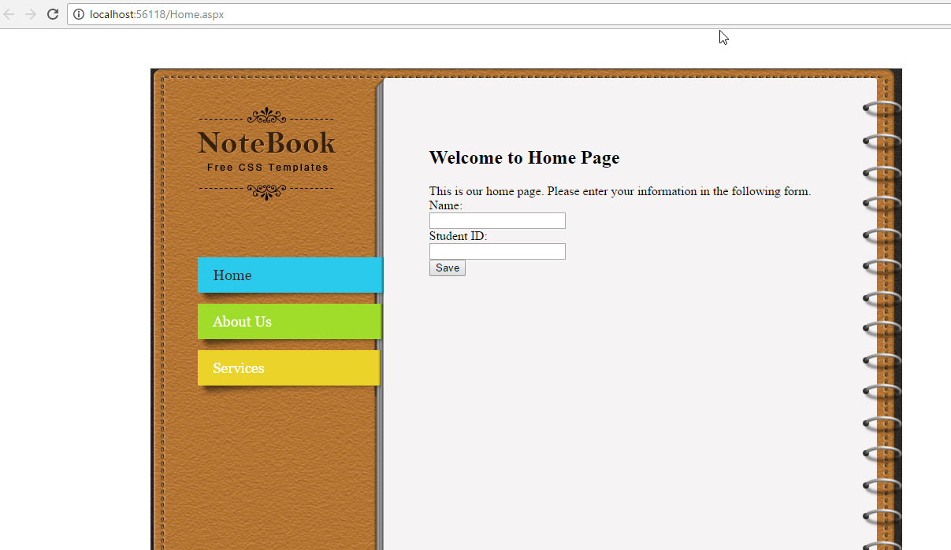

Now create an ‘About Us’ page and link it to your project.

